Тема: «Choosing a career. Would you like to be….?»
Цель: Содействовать учащимся в выборе будущей профессии, развивать навыки монологической речи по теме «Выбор профессии», совершенствовать лексические навыки и расширять лексический запас слов, стимулировать интерес к трудовой и учебной деятельности.
Соп. задача: Повторение «Conditionals»
Задачи:
Образовательные: развивать навыки монологической речи; активизировать ранее изученную лексику в устной речи и аудировании; развивать навыки и умения общаться на английском языке;
Развивающие: развивать интеллектуальные способности учащихся; формировать умения выделять главное, сравнивать и анализировать;
Воспитательные: развивать у учащихся самостоятельность мышления; содействовать профориентации учащихся; формировать потребности в практическом использовании языка;
Ход урока:
Teacher: Before we start I want you to solve a problem.
Imagine that you are a boss of a company. You will have to hire one of the two employees. One of them is a very efficient worker. The other is not, but he is your close relative. What would you do?

Pupil 1: If I were a boss I would never hire any of my relatives.
Pupil 2: I am in two minds.
Pupil 3 : I will hire an efficient worker. It will be benefiсial for my company.
Now read the poem on the board and say what it is about.
“I want to be”
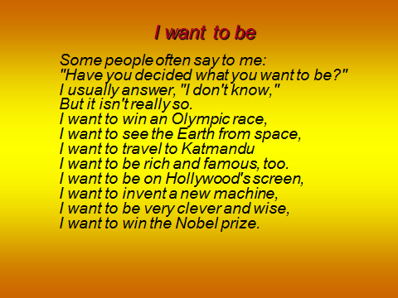
- Целеполагание. Определение плана работы.
So, what are we going to talk about? Yes, you are right. We are going to speak about the world of jobs. (картинка).Today there are thousands of different kinds of jobs, and new ones are constantly appearing. They are – teachers, doctors, drivers, pilots, lawyers, dress-makers and others. And now again a poem. What is it about?
If we could know which road to take,
If we were told which choice to make,
We wouldn’t need to hurry,
And nobody would worry,
Life would be just a piece of cake.
- Yes, you are quite right. It is not an easy thing to make the right choice.
Актуализация имеющихся знаний . (картинка профессии)
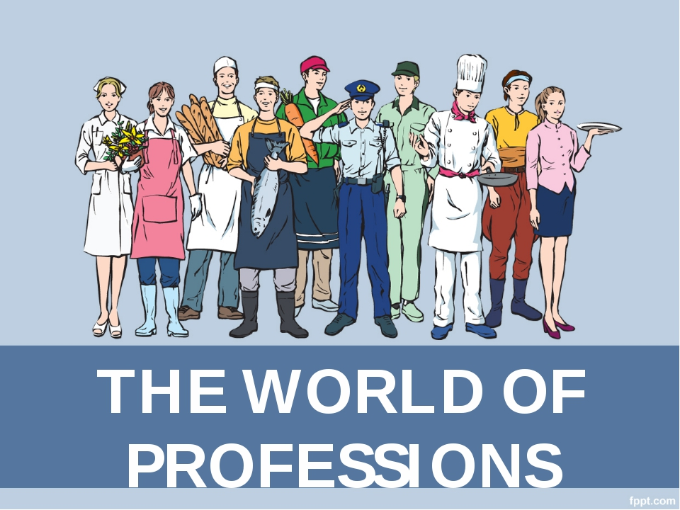

Teacher
When choosing a future career, it’s a good idea to take different factors into account. You should think about job satisfaction, money, friendly atmosphere, good conditions, training and travel. Money is an important factor when people choose a job. Do you agree with me? What is more important for you in your future job? (ученики дают ответы)
Now look at the board, please. It’s hard job to choose the right occupation and it takes a lot of efforts and energy to reach your goals in life. I think you agree with me.
Картинка «Steps to Success».
3)Активизация лексики по теме «Черты характера»
First, when choosing a career a person should also take into account different traits of character.
What traits of character are necessary to become successful?
Polite, elegant, generous, easygoing, sociable, reliable, practical, careful,
serious, creative, enthusiastic, tolerant…
What else is necessary to become successful? Let’s start with your work at school.
Предполагаемые ответы учеников:
-work hard at lessons:
-read a lot:
-attend optional classes;
-have talks with specialists;
-not to miss lessons;…
-pass exams successfully;
-enter a university:
-study hard there;
-graduate from the university:
-again work hard, hard and hard.
Now I’d like you to use conditionals in your speech. First, look at the board and let’s revise our grammar (работа с таблицей). Now you will work in pairs and try to give a piece of advice to achieve a success in your future life.
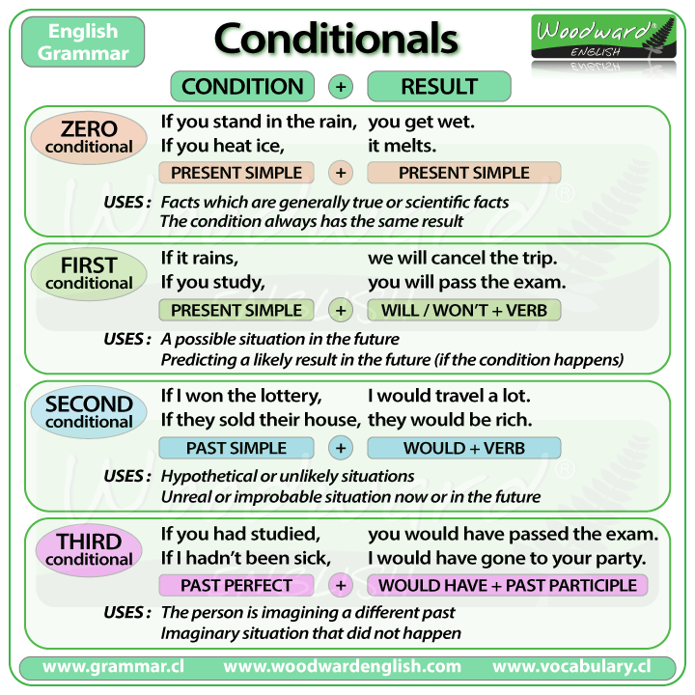
1.Use Conditional 1 to give advice to smb., who wants to become an efficient doctor ( engineer,sportsman).
2.Use Conditional 2 to give advice to smb.,who doesn’t work hard, but wants to become a successful manager.
3.Use Conditional 3 to give advice to smb.,who didn’t do well at school and now is jobless.
OK, well done. Now, answer my questions, please.
- Have you made up your mind what to become after leaving school?
- Who can help you to choose a profession? (My parents, teachers, friends help me to choose a profession)
- What subjects are important for your profession? (physics, chemistry, biology, Russian …)
- Can school help you to make your choice?
- How is school education connected with your future life?
(рассказы учеников)
I hope that our school gives you the right education and you will be a success.
Now let’s listen to some texts about choosing a career and do some tasks. (аудирование). Be very attentive. You have some time to read the task.
Your homework is to write a letter.
H\W
- You have received a letter from your English-speaking pen friend, Ben.
- … Yesterday I did a test to see which job is the most appropriate for me. According to the results I should become a doctor. But it would be absolutely impossible because I am afraid of blood…
- … What future career would you like to have, why? Do your parents agree with your choice? In what way will English be useful for your career?
- Write him a letter and answer his 3 questions.
- Write 100–120 words.
- Remember the rules of letter writing.
Рефлексия

